Easter Traditions in the UK
It is customary to give the family
the most unique chocolate egg.

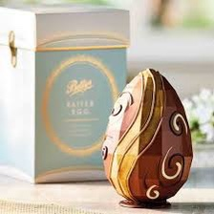
Hot cross buns, traditional raisin rolls, boiled eggs, roast lamb,
pudding and Simnel Cake reign supreme on the tables during this period.

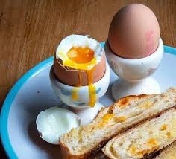
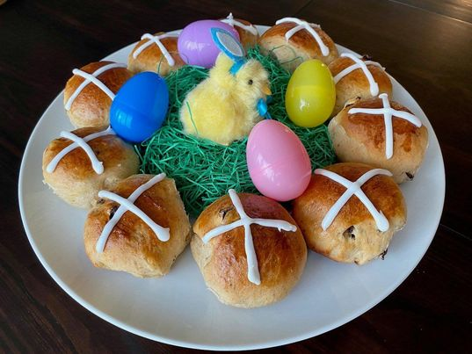
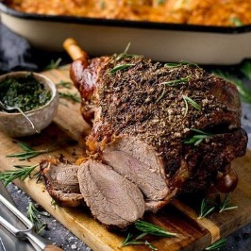
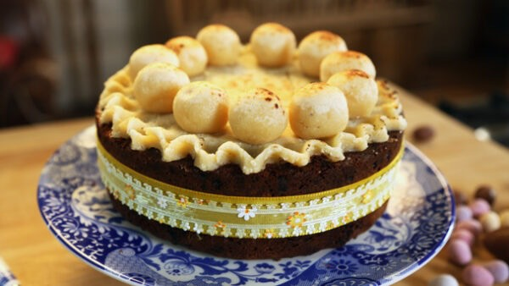
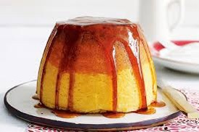
Easter vocabulary
blown egg – wydmuszka
dyed eggs – malowane jajka
to dye – farbować
egg hunt – dosłownie „polowanie na jajka”, czyli zabawa w szukanie poukrywanych kolorowych jajeczek z czekolady lub napełnionych słodyczami
blessed Easter food – święconka
chocolate eggs / Easter eggs – czekoladowe jajka
Easter basket – koszyk wielkanocny
easter lamb – baranek wielkanocny
feasting – ucztowanie, świętowanie
chick – pisklę, kurczaczek
to splash with water – oblewać wodą
bucket – wiadro
water gun – pistolet na wodę
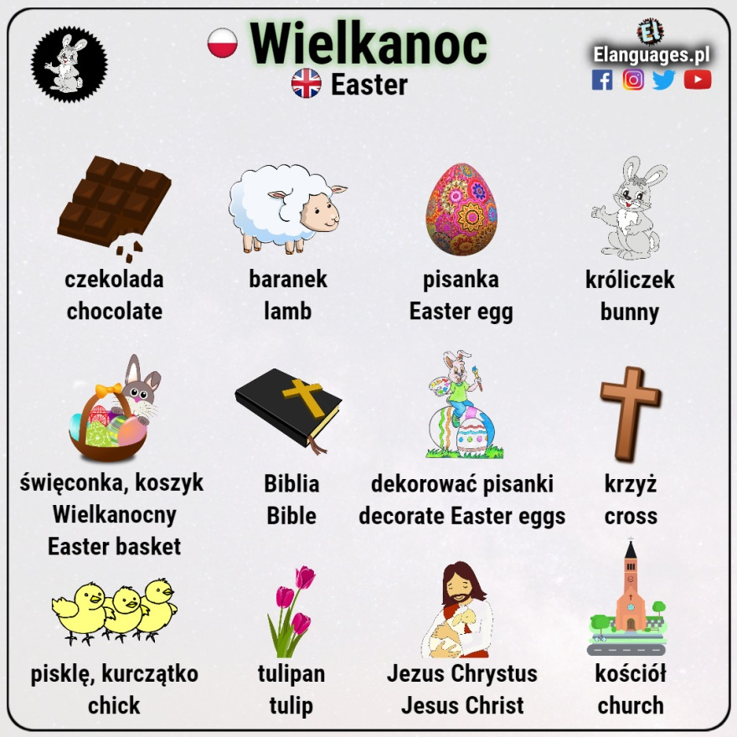
by Lena by Ksenia

Eggs with mayonnaise

Ingredients :
- three eggs
- some mayonnaise
- chives
- salt
- pepper

How make it?
First, boil the eggs for 10 minutes. Then, peel them from the
shell and cut them in half. After that, put on it some salt and
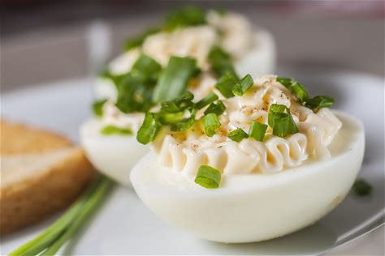
pepper. Finally put on mayonnaise and sliced chives.
By Paulina

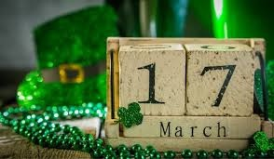
ST. PATRICK’S DAY

5 things you should know about St. Patrick’s day:
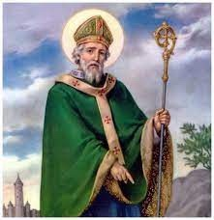
1. St. Patrick is Ireland’s most famous patron and
March 17th is the date of the Saints death and this
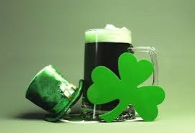
holiday has been celebrated for about 1500 years.

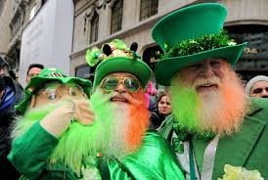
2. Four-leaf clover is a symbol of Saint Patrick.

3. On this day everyone dresses up in green, all this to
honor the memory of the Saint.
4. The pot of gold at the end of the rainbow is also
associated with Patrick’s Day, symbolizes the
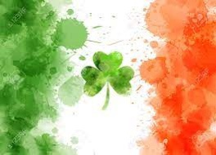
pursuit to dreams.

5. Green is the national color of Ireland, referring to
the grassy landscape of the Island. By Izabela Kozłowska 6c

